* For the legs, can there be a product tag/info tag that explains it a bit? Appears like this, when user click on the dot, it tells them what is different for each leg type

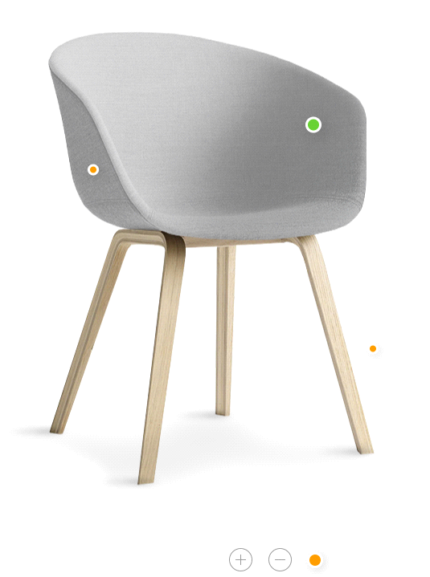

* Chair can have darker color option (so one is light, and one is dark grey)

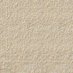

* User can enter Size with drawing in 2D in this section

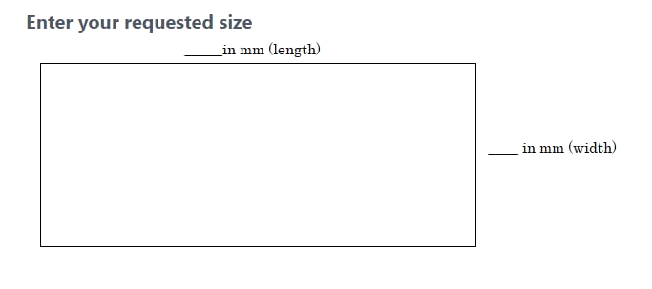

* Wood Thickness

Can we do one more varitaion for solid wood traditional 3 colors with a thicker option (45mm)

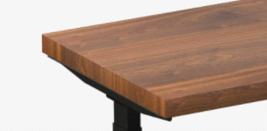

Also I want the maple one to be lighter color, I asked last time…

* Linked to Our Youtube Channel
* For accessores, Can it allow user to enlarge the thumbnail with some explaination? How much more if I want to model all the accessories
* For the new stuff, can we have a menu sturcture, like in Apple OS

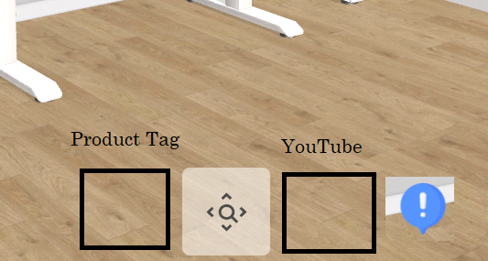

* The live edge is still no good…I want it improved…The handset Is not properly displayed as mentioned last time

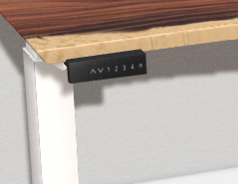

None of these texture works?

<https://drive.google.com/file/d/1LJBccgdu_OvBlI6hWO7CUCF5p2HDyc70/view>

<https://www.sierralivingconcepts.com/product/10503/olivet-suar-wood-single-slab-large-live-edge-dining-table-top>

<https://www.turbosquid.com/3d-models/max-hudson-solid-acacia-table/880843>

* Each Color Can I put names next to numbers?